Module Name: Flipkart Login Module
Test Case ID: TC_LOGIN_001
Webpage URL: https://www.flipkart.com/account/login?ret=/

Scenario ID: 1A
Scenario: Testing Mobile Number input field with a valid number
Test Steps:
- Open Flipkart
- Click Login
- Enter a valid number
- Request OPT
Screenshot :
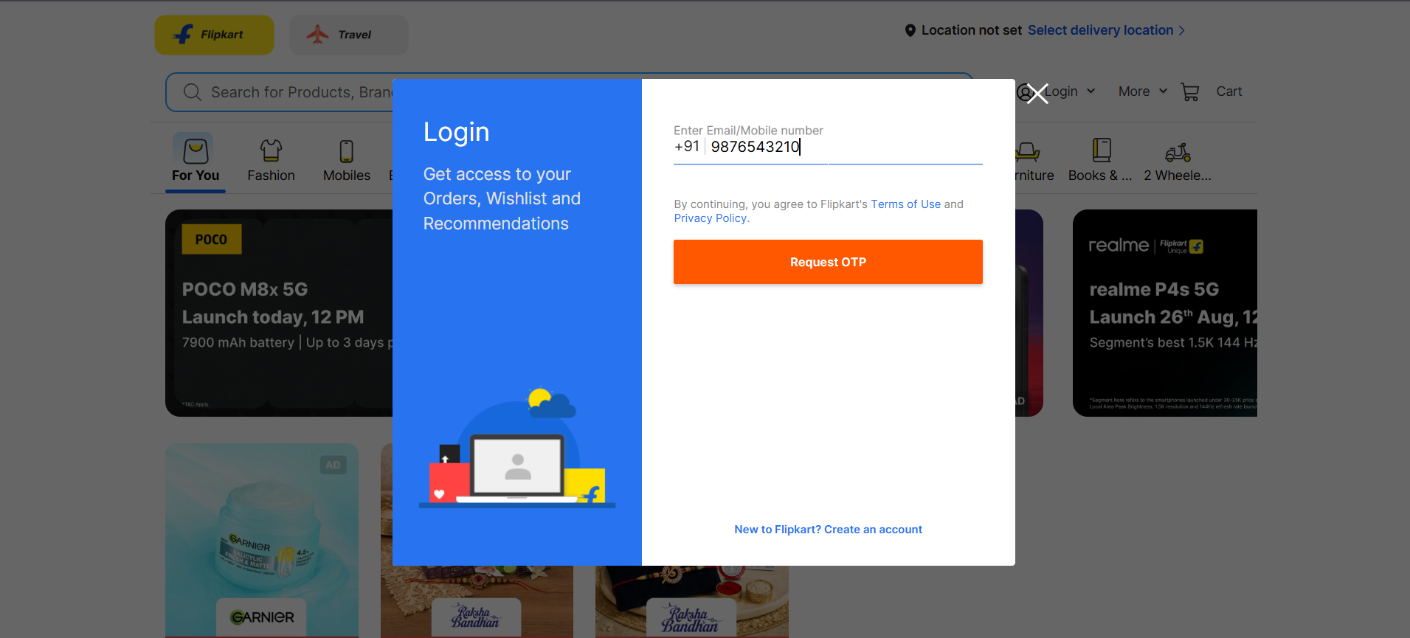

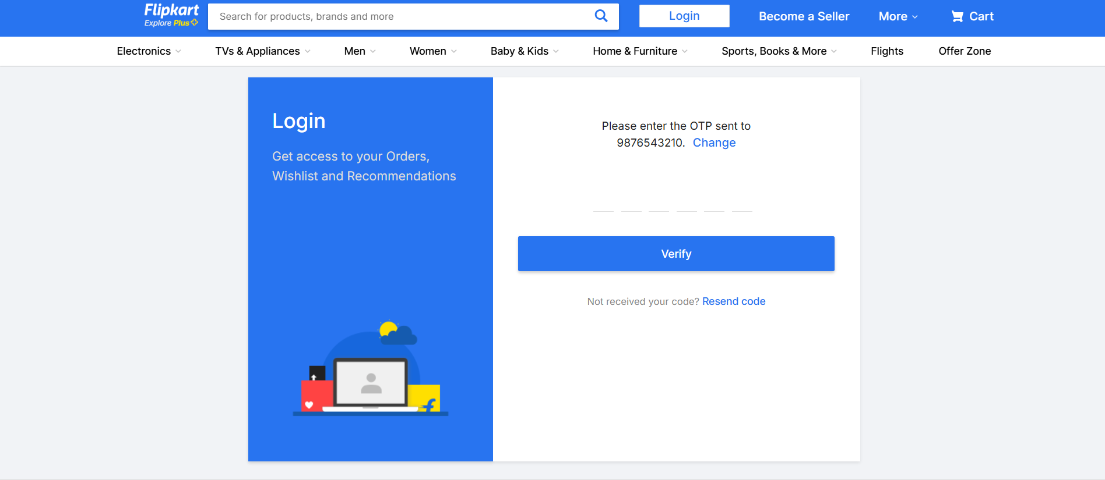

Scenario ID: 2A
Scenario: Leaving blank the mobile number field
Test Steps:
- Open Flipkart
- Click Login
- Leave Mobile Number blank
- Request OPT
Screenshot :
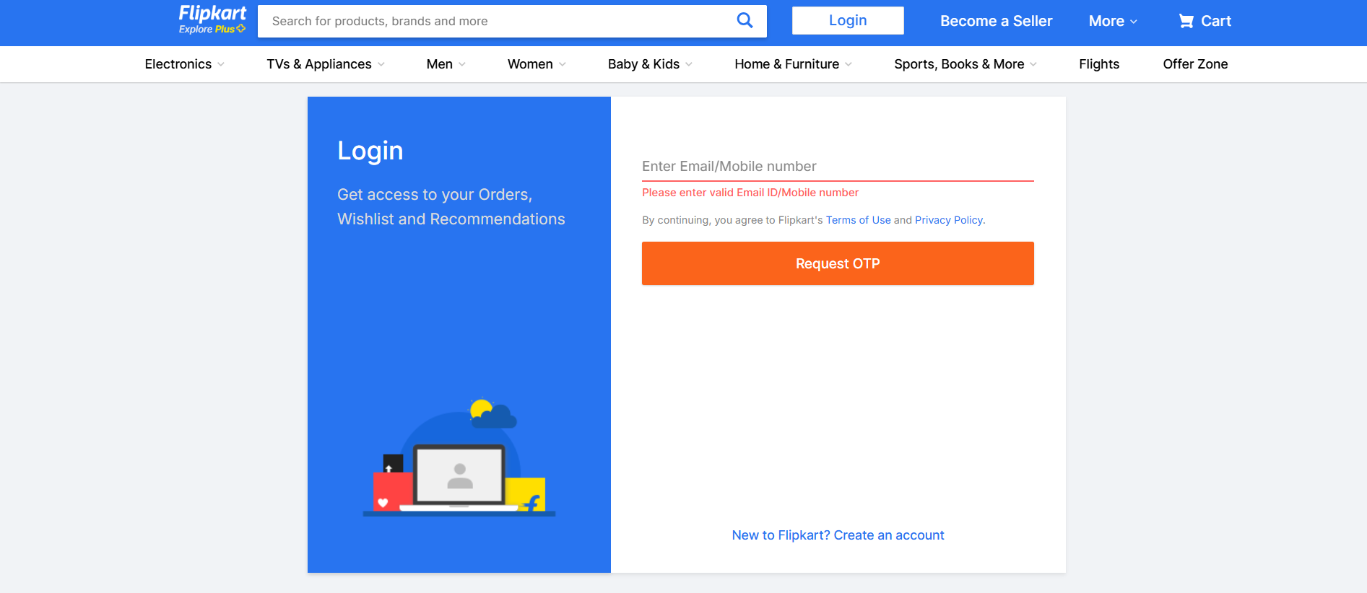

Scenario ID: 3A
Scenario: Testing Mobile Number input field with a invalid number
Test Steps:
- Open Flipkart
- Click Login
- Input Invalid Mobile Number
- Request OPT
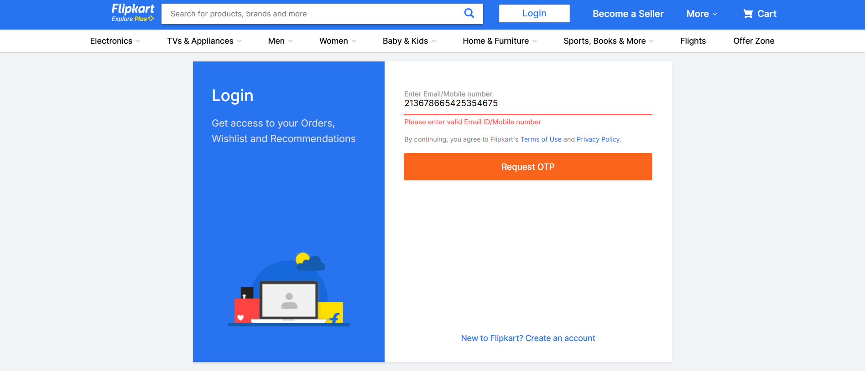

Scenario ID: 1A
Scenario: Testing Mobile Number input field with a invalid number with letters
Test Steps:
- Open Flipkart
- Click Login
- Input Invalid Mobile Number with letters
- Request OPT

